**Name: Abdalrahman Omar Latif**

**Project: SQL Assignment - WorldDB**

**Submission Date: 10th May, 2024**

**Table of Content**

|  |  |
| --- | --- |
| **Title** | **Page** |
| **Task 1** | **3** |
| **Task 2** | **4** |
| **Task 3** | **5-6** |
| **Task 4** | **6** |
| **Task 5** | **7** |
| **Task 6** | **8** |
| **Task 7** | **9** |
| **Task 8** | **10** |
| **Task 9** | **10-12** |
| **Task 10** | **12-13** |
| **Task 11** | **14** |
| **Task 12** | **15** |
| **Task 13** | **15** |
| **Task 14** | **16** |
| **Task 15** | **16-17** |
| **Task 16** | **17** |
| **Task 17** | **18** |
| **Task 18** | **18** |
| **Task 19** | **19** |
| **Task 20** | **19** |

**Task1**

**Count Cities in USA:** *Scenario:* You've been tasked with conducting a demographic analysis of cities in the United States. Your first step is to determine the total number of cities within the country to provide a baseline for further analysis.

select  count(countrycode) as totalUSAcities  from city

  where countrycode='USA'

**This query counted number of US cities based on country code**

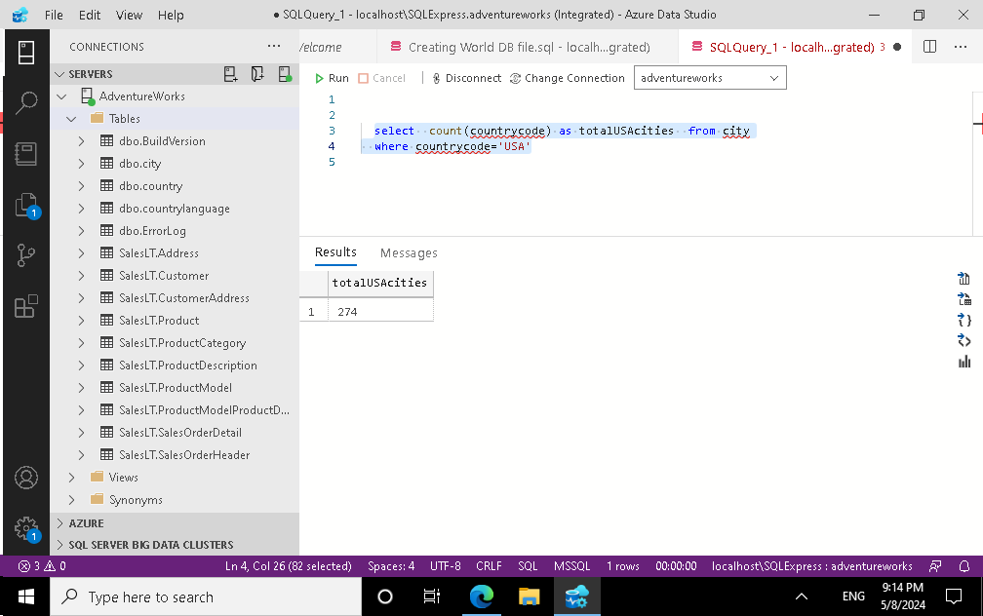

**Task 2**

1. **Country with Highest Life Expectancy:** *Scenario:* As part of a global health initiative, you've been assigned to identify the country with the highest life expectancy. This information will be crucial for prioritizing healthcare resources and interventions.

Select name, lifeexpectancy from country

where lifeexpectancy =(select max(lifeexpectancy) from country)

**(this query returns the highest life expectancy globally) It showed that Andorra has the highest Life Expectancy over the world . It is noticed that we need firs to select the life expectancy field and the use MAX() function as subquery**

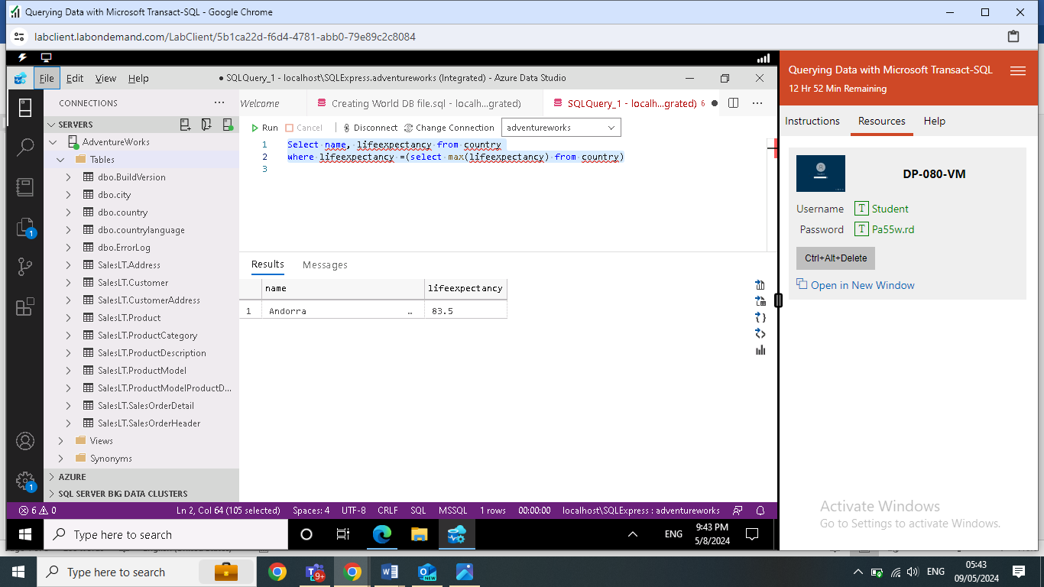

**Task 3**

**"New Year Promotion: Featuring Cities with 'New :** *Scenario:* In anticipation of the upcoming New Year, your travel agency is gearing up for a special promotion featuring cities with names including the word 'New'. You're tasked with swiftly compiling a list of all cities from around the world. This curated selection will be essential in creating promotional materials and enticing travellers with exciting destinations to kick off the New Year in style.

Select name  from city

where name like 'New%'

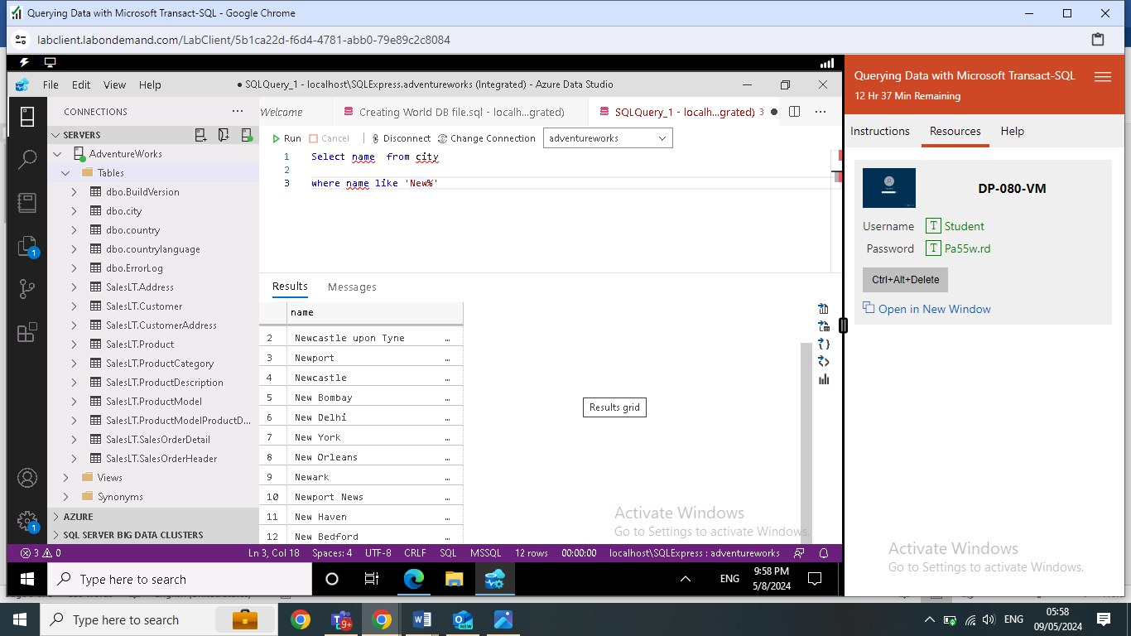

**This query returns the city starting with New , however I have conducted another query to include any city has in some part of its name ( New) as per following query below :**

Select name  from city

where name like '%New%'

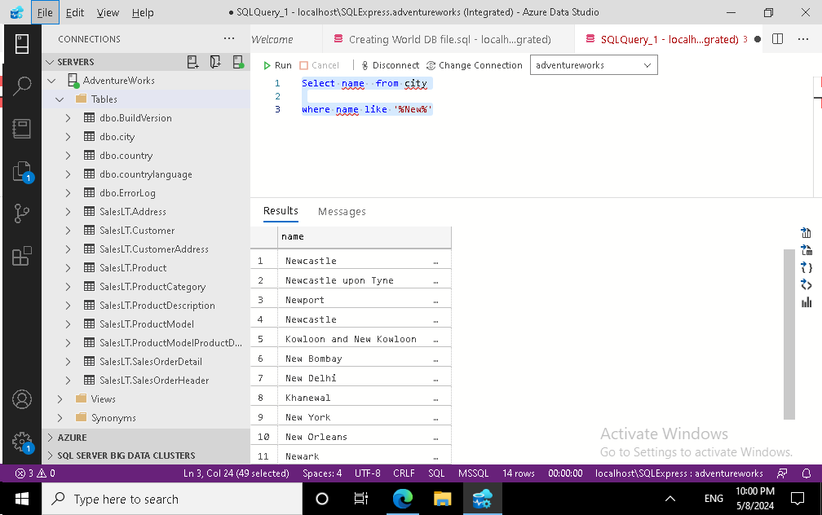

**Task 4**

**Display Columns with Limit (First 10 Rows):** *Scenario:* You're tasked with providing a brief overview of the most populous cities in the world. To keep the report concise, you're instructed to list only the first 10 cities by population from the database.

Select top(10)  name, population  from city

 order by population DESC ;

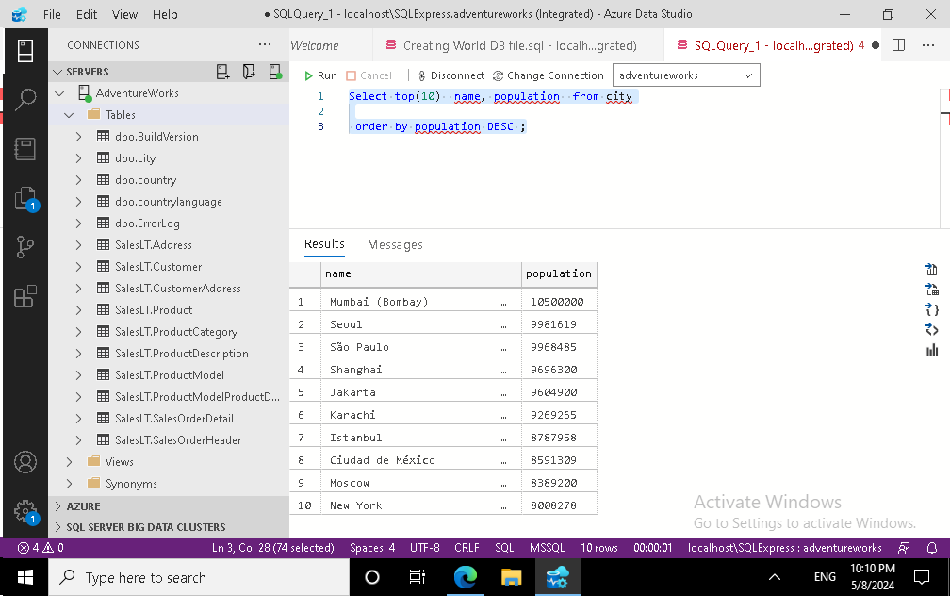

**Task 5**

**Cities with Population Larger than 2,000,000:** *Scenario:* A real estate developer is interested in cities with substantial population sizes for potential investment opportunities. You're tasked with identifying cities from the database with populations exceeding 2 million to focus their research efforts

Select  name, population  from city

 where population >2000000 ;

**To give the correct figure , the query written here is returning the population more than 2 million inhabitants and using larger than sign as shown above .**

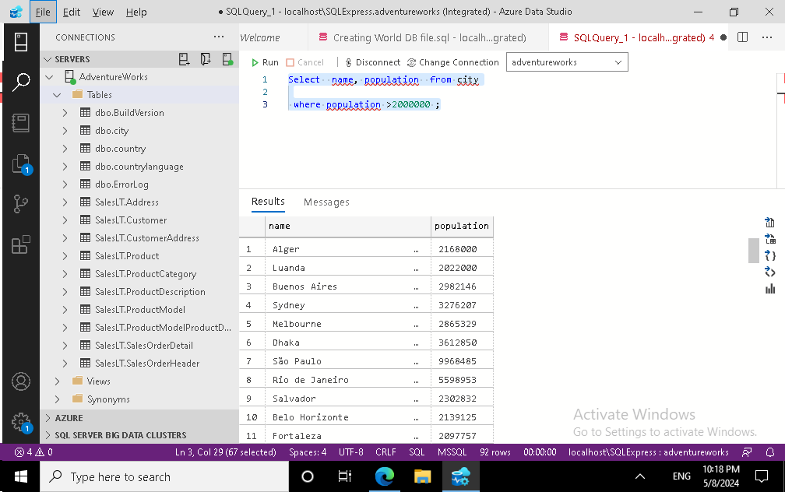

**Task 6**

**Cities Beginning with 'Be' Prefix:** *Scenario:* A travel blogger is planning a series of articles featuring cities with unique names. You're tasked with compiling a list of cities from the database that start with the prefix 'Be' to assist in the blogger's content creation process.

select  name from city

where name like 'be%'

select count(name) as namesPrefixBE from city

 where name like '%be'

**The second query returned the number of cities that prefix with Be**

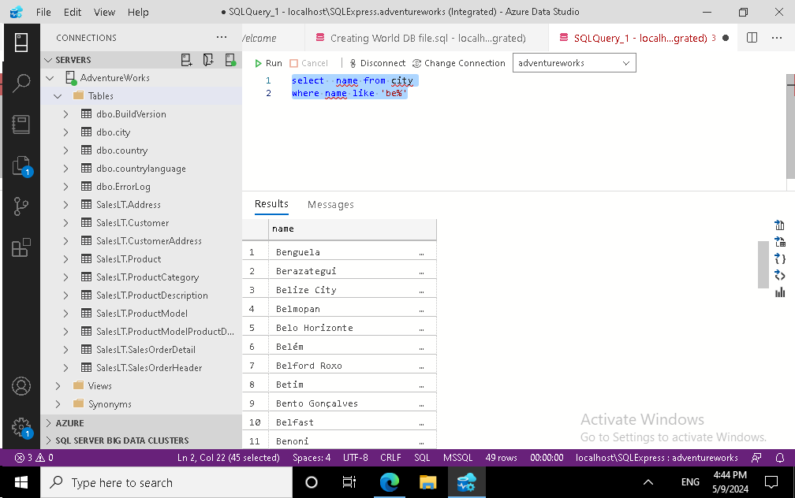

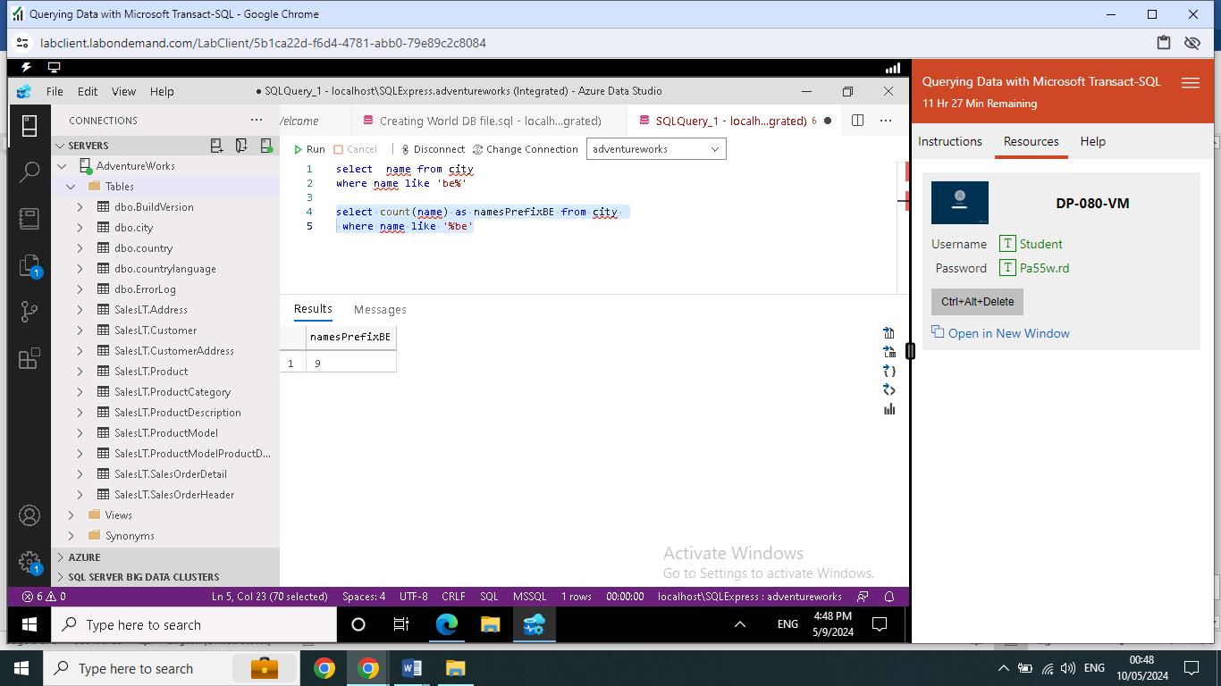

**Task 7**

**Cities with Population Between 500,000-1,000,000:** *Scenario:* An urban planning committee needs to identify mid-sized cities suitable for infrastructure development projects. You're tasked with identifying cities with populations ranging between 500,000 and 1 million to inform their decision-making process.

Select name, population  from city

 where population between 500000 and 1000000

select count(population) as citiespopultion from city where  population between 500000 and 1000000

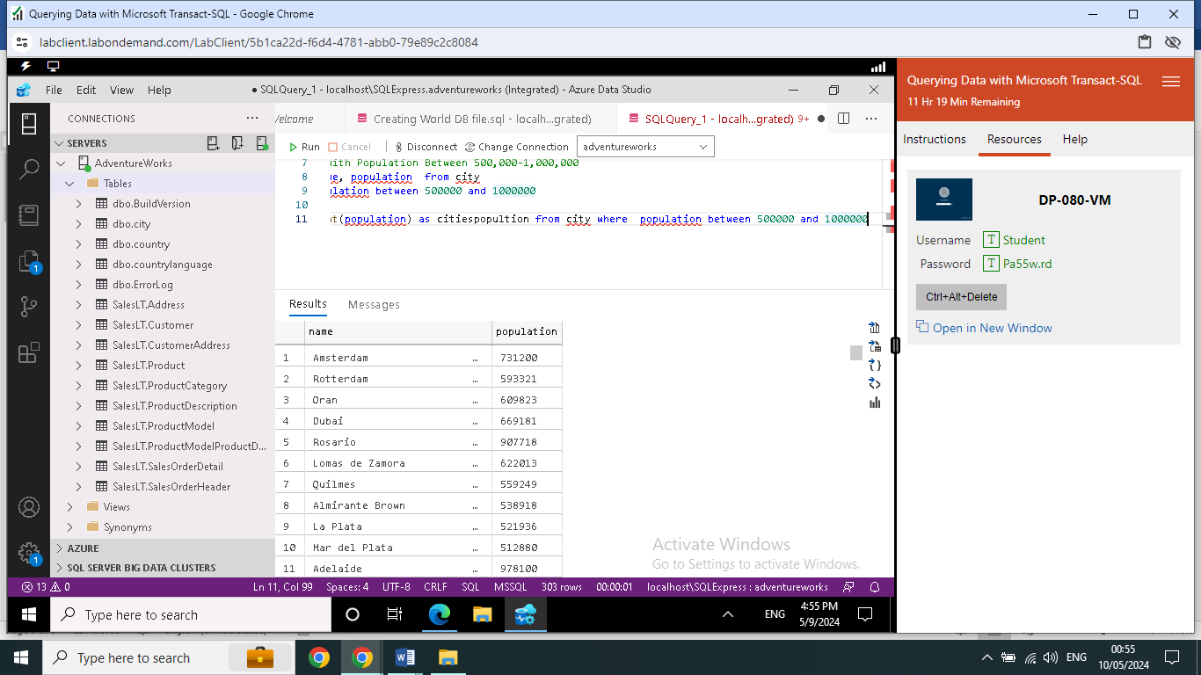

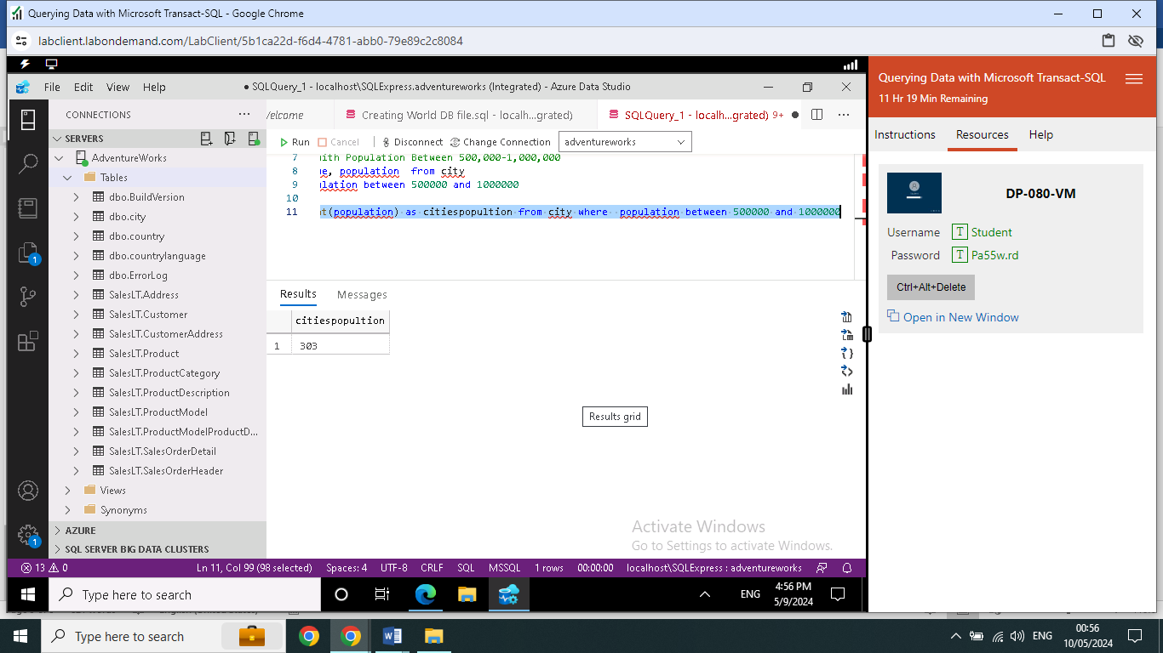

**Task 8**

**Display Cities Sorted by Name in Ascending Order:** *Scenario:* A geography teacher is preparing a lesson on alphabetical order using city names. You're tasked with providing a sorted list of cities from the database in ascending order by name to support the lesson plan.

select  name from city

order by name ASC

**Although this query returns cities name sorted by ascending , cities names started with alphabatica with symbol listed first**

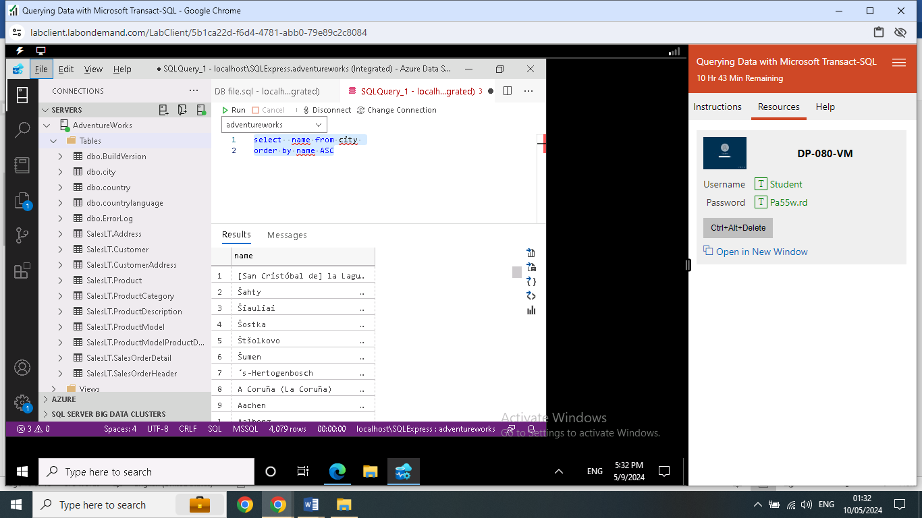

**Task 9**

**Most Populated City:** *Scenario:* A real estate investment firm is interested in cities with significant population densities for potential development projects. You're tasked with identifying the most populated city from the database to guide their investment decisions and strategic planning.

select top(10) name , population  from city

order by population desc

select top(20) name , population  from city

order by population desc

select top(30) name , population  from city

order by population desc

**in this query results showing the top 10 cities with highest population. However, can be extended the query to included more cities using top (20) or top (30).**

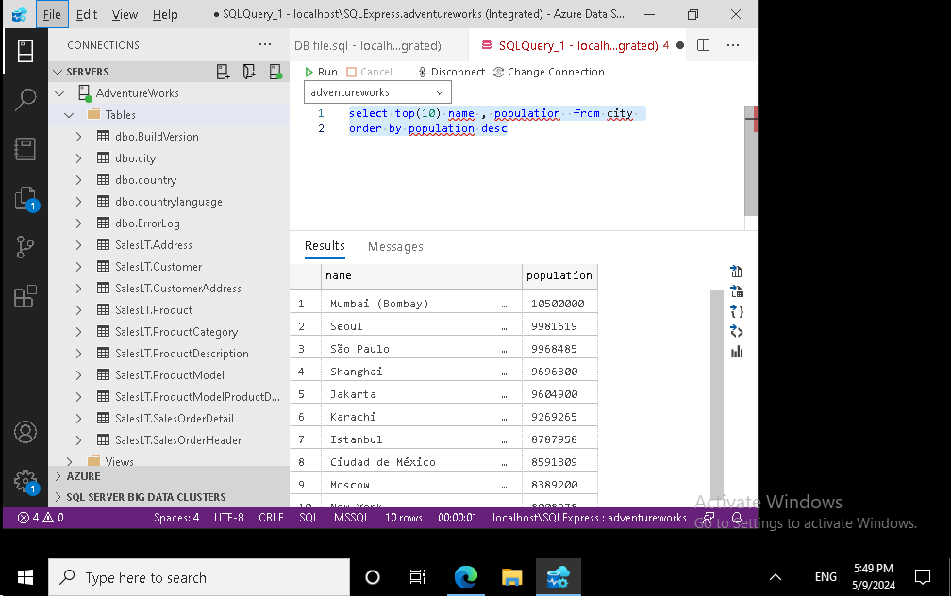

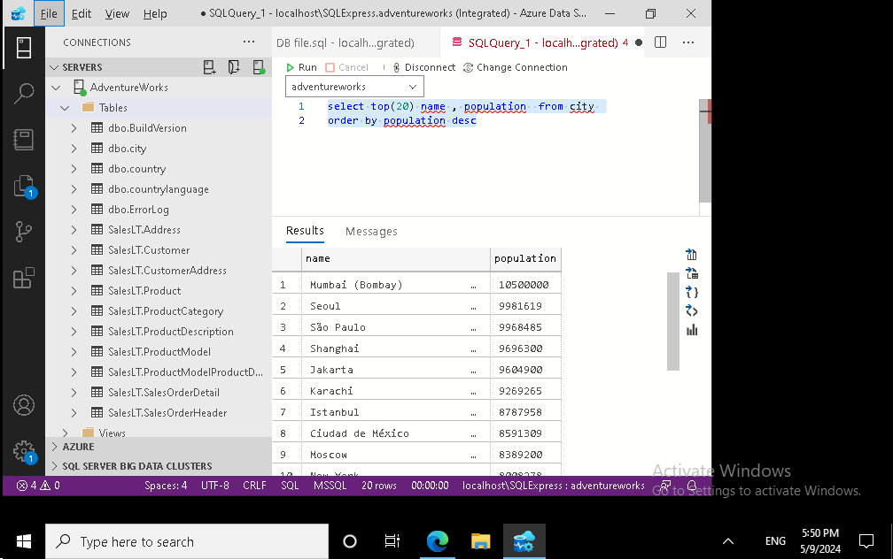

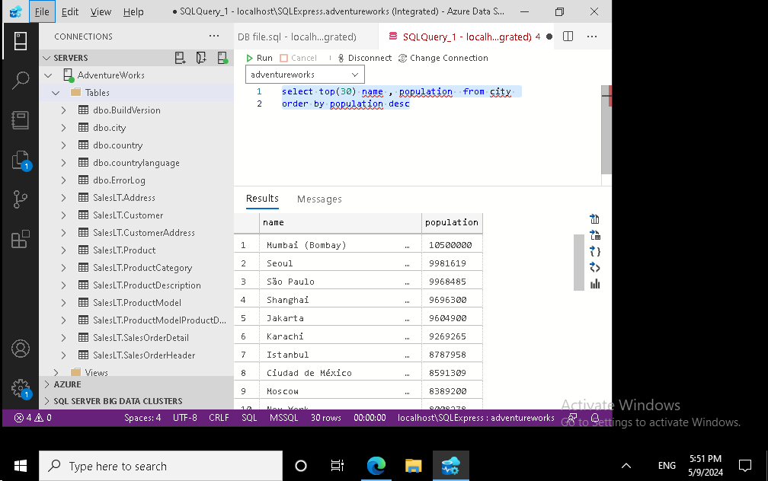

**Task 10**

**City Name Frequency Analysis: Supporting Geography Education** *Scenario*: In a geography class, students are learning about the distribution of city names around the world. The teacher, in preparation for a lesson on city name frequencies, wants to provide students with a list of unique city names sorted alphabetically, along with their respective counts of occurrences in the database. You're tasked with this sorted list to support the geography teacher's l

select distinct (name)    from city

order by name asc

SELECT name, COUNT(*) AS count

FROM city

GROUP BY name

ORDER BY count DESC;

**The first query returns the cities name without repeated , while the second query counting the repeated cities names**

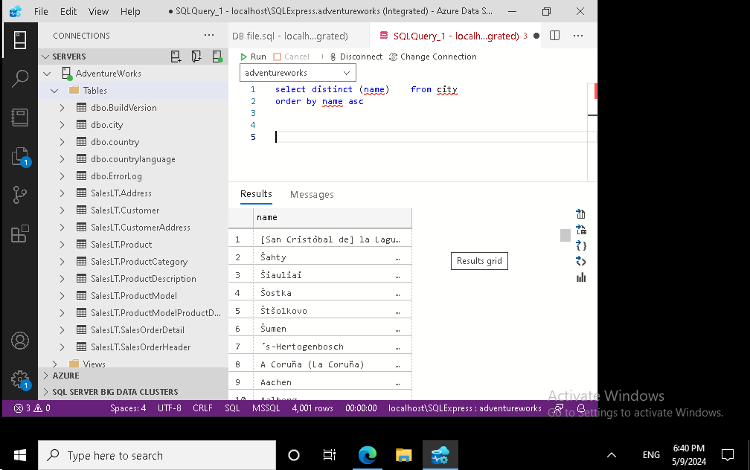

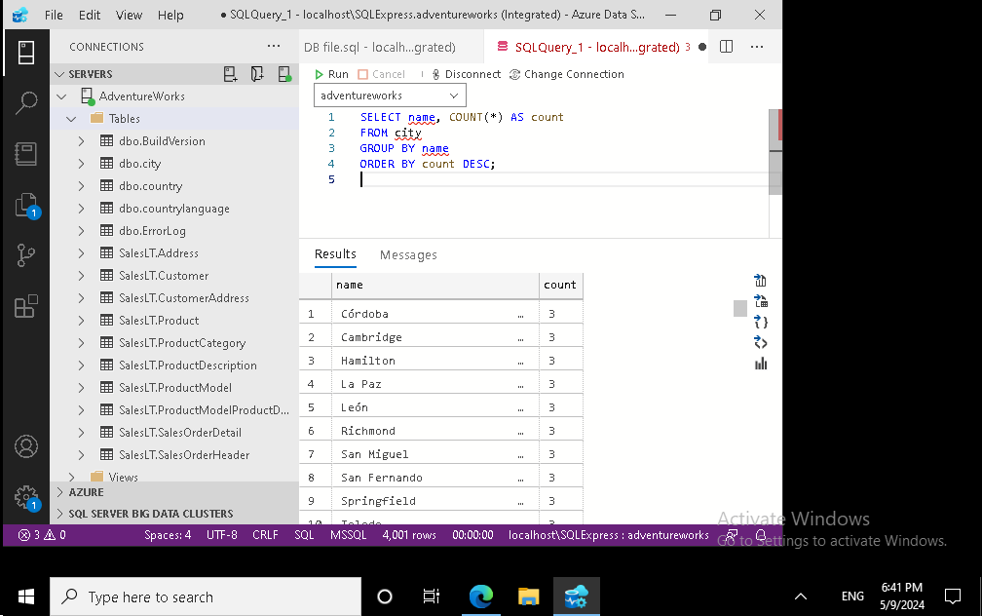

**Task 11**

**City with the Lowest Population:** *Scenario:* A census bureau is conducting an analysis of urban population distribution. You're tasked with identifying the city with the lowest population from the database to provide a comprehensive overview of demographic trends.

select name, population from city

where population = (select min(population) from city)

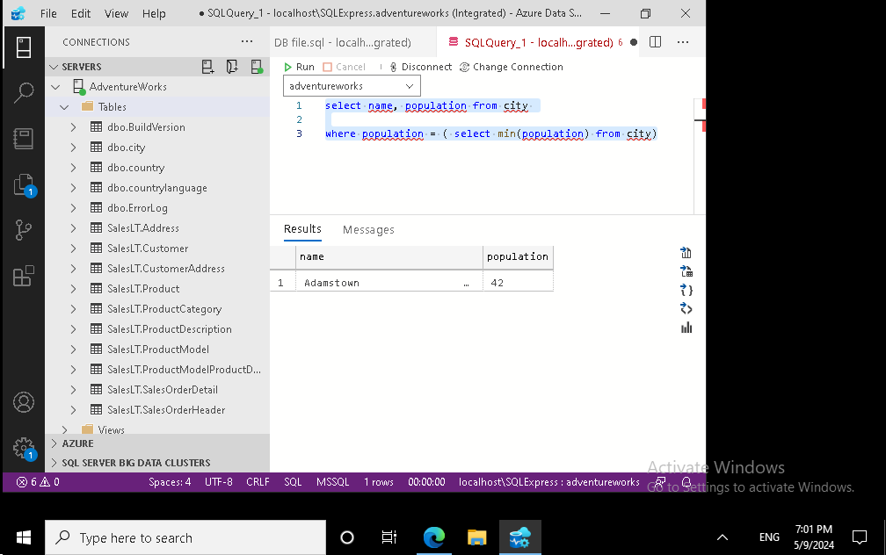

**Task 12**

**Country with Largest Population:** *Scenario:* A global economic research institute requires data on countries with the largest populations for a comprehensive analysis. You're tasked with identifying the country with the highest population from the database to provide valuable insights into demographic trends.

select name, population  from country

where population = (select max(population) from country)

**returns the China is highest population over the world , by using subquery**

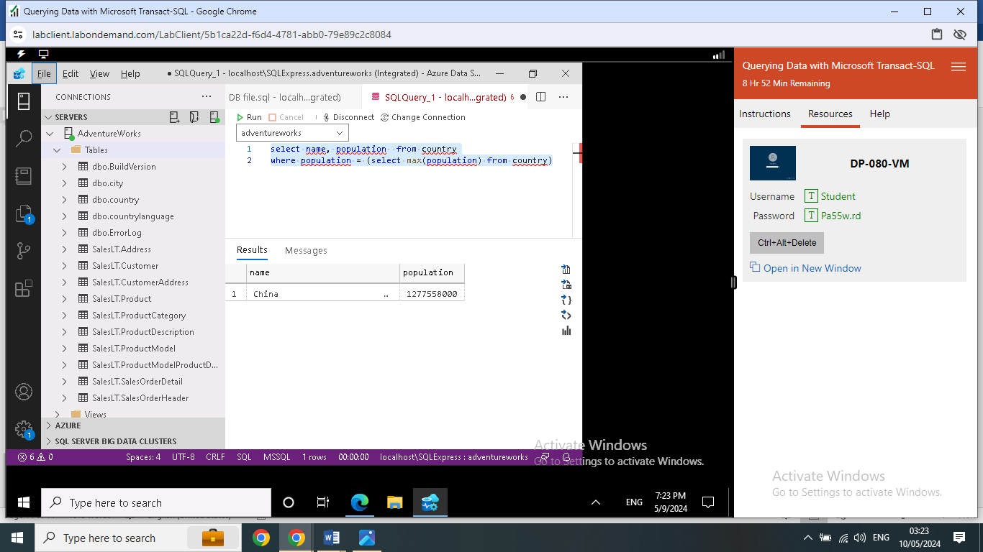

**Task 13**

**Capital of Spain:** *Scenario:* A travel agency is organizing tours across Europe and needs accurate information on capital cities. You're tasked with identifying the capital of Spain from the database to ensure itinerary accuracy and provide travelers with essential destination information.

**Task 14**

**Country with Highest Life Expectancy:** *Scenario:* A healthcare foundation is conducting research on global health indicators. You're tasked with identifying the country with the highest life expectancy from the database to inform their efforts in improving healthcare systems and policies.

select  name, lifeexpectancy  from country

 where lifeexpectancy =(select max(lifeexpectancy) from country)

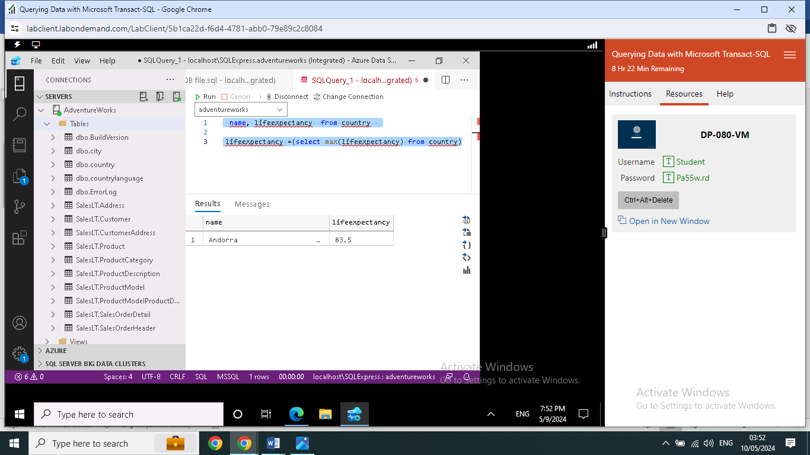

**Task 15**

**Cities in Europe:** *Scenario:* A European cultural exchange program is seeking to connect students with cities across the continent. You're tasked with compiling a list of cities located in Europe from the database to facilitate program planning and student engagement.

select    name, region from country

where region like '%Europe%'

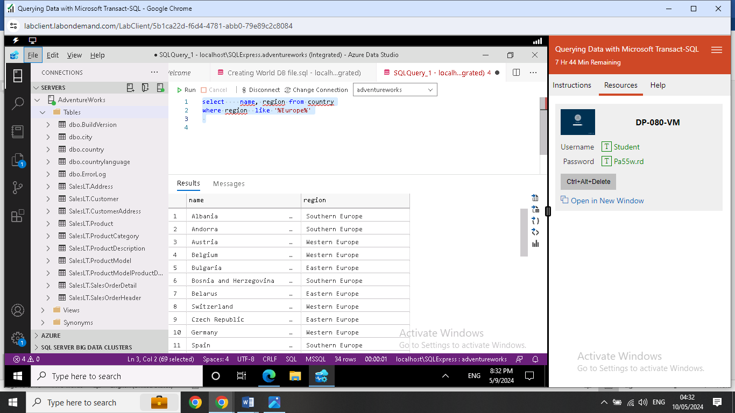

**Task 16**

**Average Population by Country:** *Scenario:* A demographic research team is conducting a comparative analysis of population distributions across countries. You're tasked with calculating the average population for each country from the database to provide valuable insights into global population trends.

select avg(population) as averagepopulation , name from country

group by name

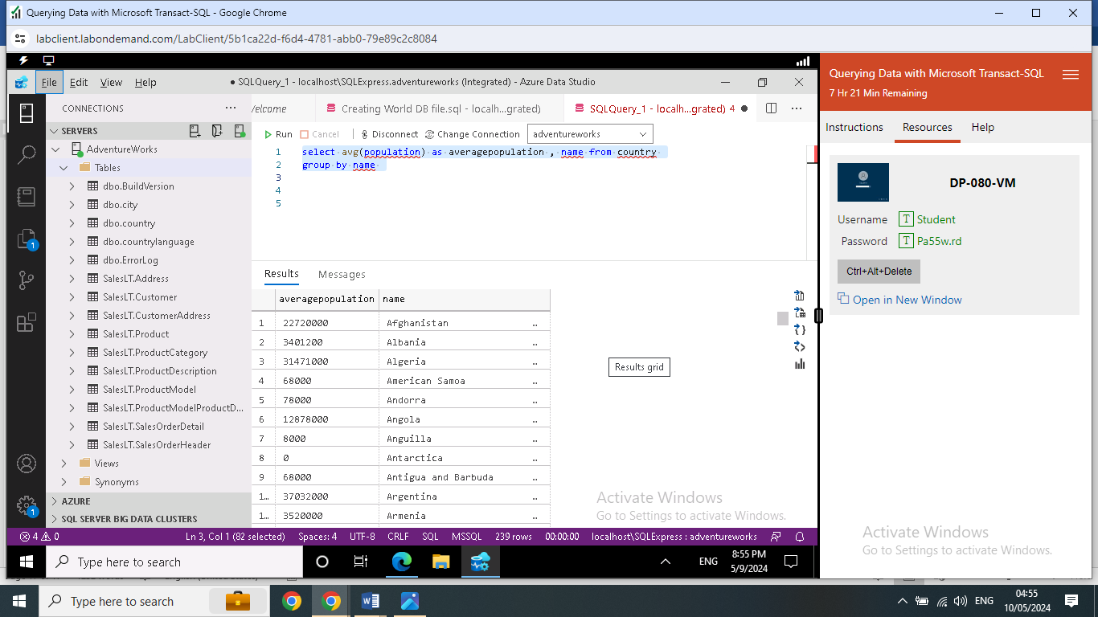

**Task 17**

**Capital Cities Population Comparison:** *Scenario:* A statistical analysis firm is examining population distributions between capital cities worldwide. You're tasked with comparing the populations of capital cities from different countries to identify trends and patterns in urban demographics.

**Task 18**

**Countries with Low Population Density:** *Scenario:* An agricultural research institute is studying countries with low population densities for potential agricultural development projects. You're tasked with identifying countries with sparse populations from the database to support the institute's research efforts.

select  population , name  from country

 where population > 0 and population < 1000000

**This query returns the population range of countries across the world. This Query could be used for several possibilities.**

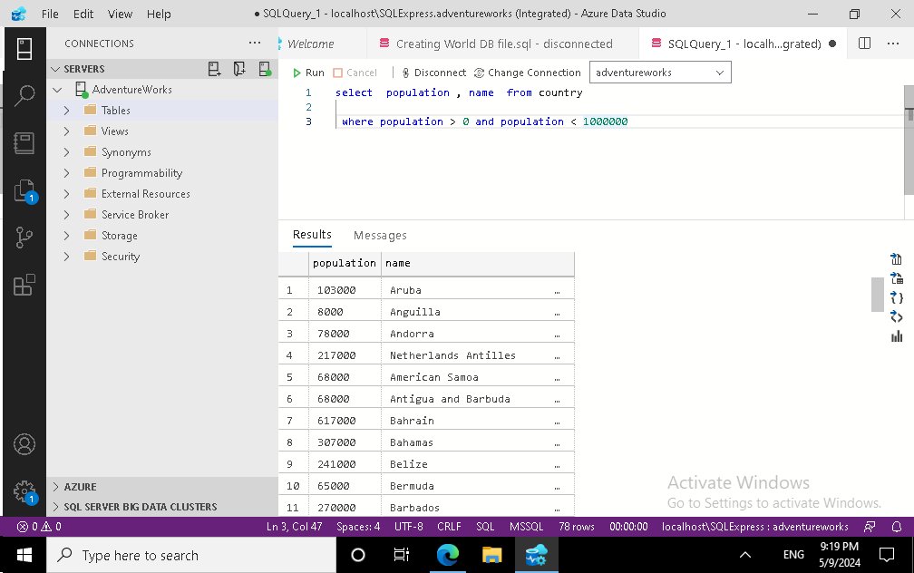

**Task 19**

**Cities with High GDP per Capita:** *Scenario:* An economic consulting firm is analyzing cities with high GDP per capita for investment opportunities. You're tasked with identifying cities with above-average GDP per capita from the database to assist the firm in identifying potential investment destinations.

select  name, gnp   from country

where gnp > (select avg(gnp) from country)

**This question requested to conduct query to return GDP of cities, however GDP for countries I wrote as shown below**

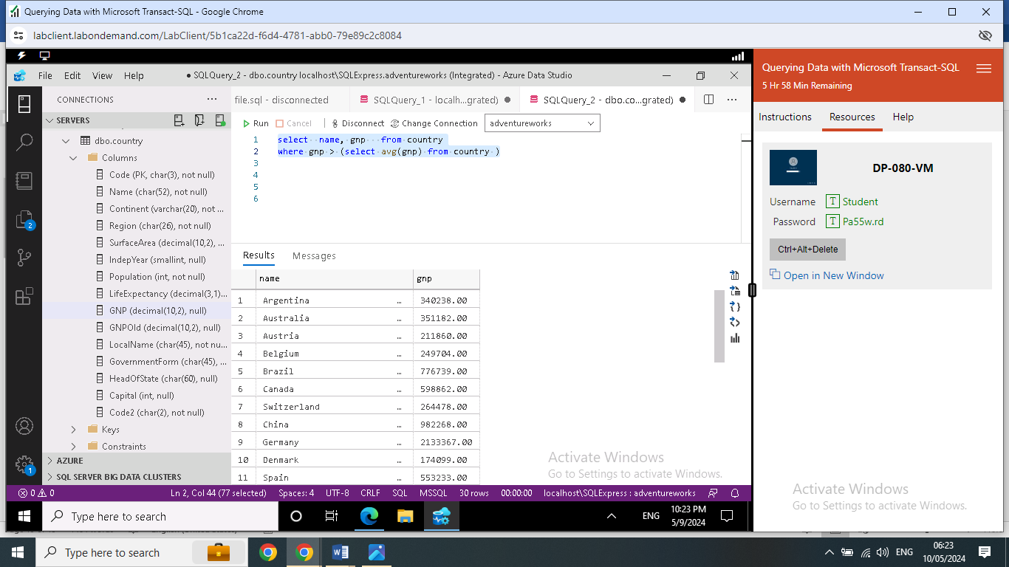

**Task 20**

**Display Columns with Limit (Rows 31-40):** *Scenario:* A market research firm requires detailed information on cities beyond the top rankings for a comprehensive analysis. You're tasked with providing data on cities ranked between 31st and 40th by population to ensure a thorough understanding of urban demographics.